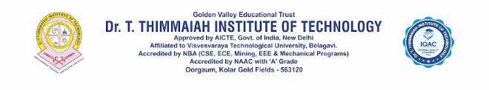 Department of Computer Science and Engineering
Hardware and Software Details DIGTAL CENTER
COMPUTER LAB-I(Mathematics)2026-2027

Sl.No. | Hardware Details | Quantity Available
1 | OS Name: Microsoft Windows 10 pro  Version: 10.0.19045  Processor: Inter ® Core ™i7-8700 cpu @ 3.20ghZ, 3192 mhZ, Core(s), 6 Logical Progcessor | 36

List of Software Details DIGTAL CENTER COMPUTER LAB-I(Matematics)
Sl.No | List of Software
1 | Windows 10 Operating System
2 | Git Bash - - version 2.56.0
3 | Visual Studio Code (User)1.96.2
4 | Anaconda3 2024.05-1
5 | Ms Office 2010 and Autodesk Fusion 2.0.20476

Lab Instrutor HOD/CSE
Dr.Geetha C. Megharaj

